Assignment – 09
String Functions
- Write a query to display the FIRST_NAME and LAST_NAME concatenated as Full Name for all employees.
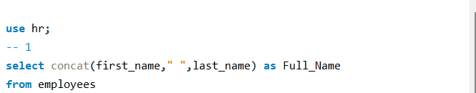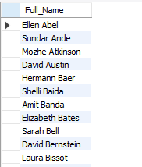
- Write a query to display the FIRST_NAME in lowercase and the LAST_NAME in uppercase for all employees.
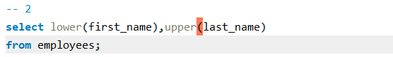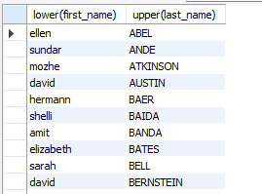
- Write a query to display the COUNTRY_NAME of all countries in uppercase.
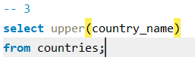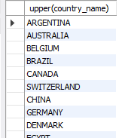
- Write a query to display the FIRST_NAME and the length of the first name for all employees.
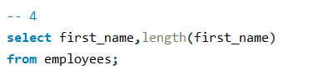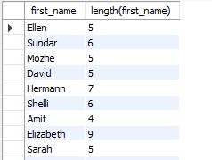
- Write a query to display the EMAIL and the length of the email address for employees whose email length is greater than 10
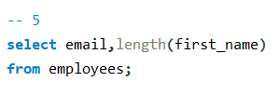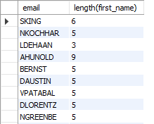
- Write a query to extract the first three characters from the FIRST_NAME of all employees.
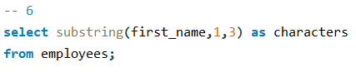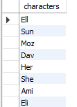
- Write a query to extract the last four characters of the PHONE_NUMBER for all employees.
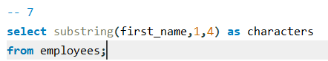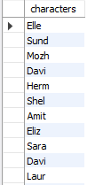
- Write a query to find the position of the letter 'a' in the LAST_NAME of all employees.
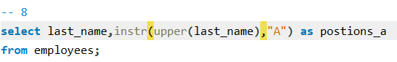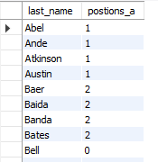
- Write a query to find the position of the substring 'IT' in the job title of all employees.
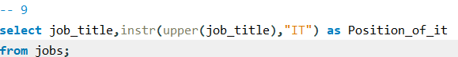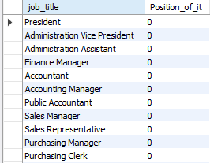
- Write a query to replace all occurrences of 'A’ with 'X' in the FIRST_NAME of all employees.
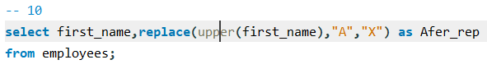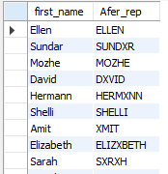
- Write a query to replace the region name 'Europe' with 'EU' in the REGION_NAME column.
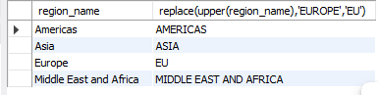
- Write a query to remove any leading and trailing spaces from the FIRST_NAME of all employees and display the cleaned-up names.
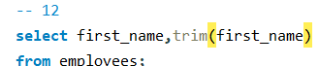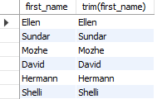
- Write a query to remove any trailing spaces from the CITY names of all locations.
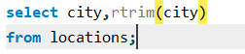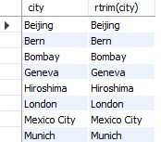
- Write a query to extract the first five characters from the EMAIL of all employees using the LEFT function.
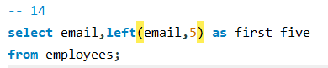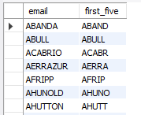
- Write a query to extract the last three characters from the COUNTRY_NAME of all countries using the RIGHT function.
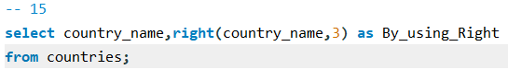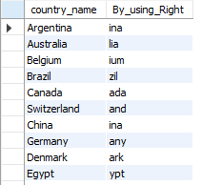
- Write a query to extract the domain (everything after '@') from the EMAIL column of all employees.
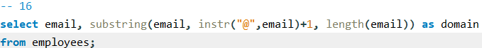
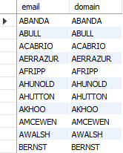
#In this database, we have no domain in the email.
- Write a query to extract the country code (first part before space) from the PHONE_NUMBER of all employees.
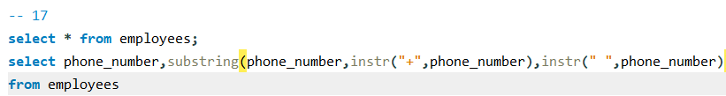
- Write a query to compare the FIRST_NAME and LAST_NAME of employees and display 0 if they are the same and a non-zero value if they are different.
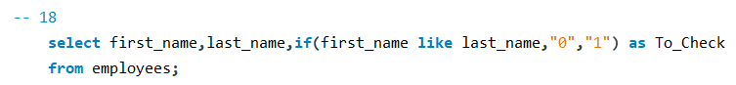
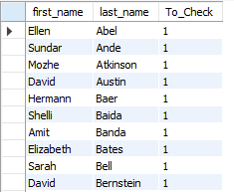
- Write a query to compare the REGION_NAME of regions and display 0 if it is 'Asia' and 1 otherwise.
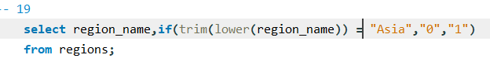
- Write a query to display the FIRST_NAME, LAST_NAME, and JOB_TITLE concatenated as a single string, with each value separated by a hyphen (-), for all employees.
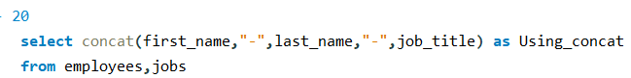
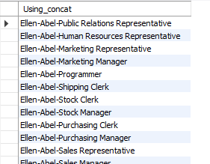
- Write a query to extract the username (portion before @) from the EMAIL column and display it along with the FIRST_NAME for all employees.
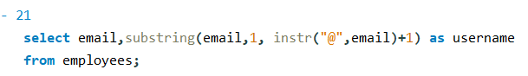
- Write a query to replace all occurrences of 'e' with 'E' in the LAST_NAME of employees whose LAST_NAME contains 'e'.
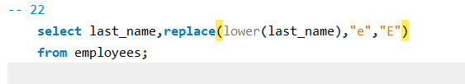
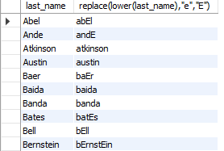
- Write a query to find the position of the first occurrence of the letter 'o' in the FIRST_NAME of employees and display the name along with the position.
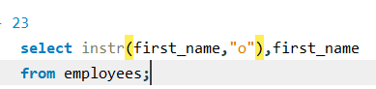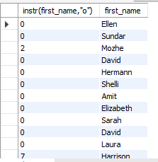
- Write a query to display the CITY name for all locations, removing any leading and trailing spaces, and also display the first three characters of the cleaned-up city name.
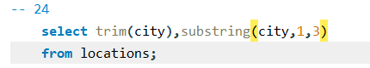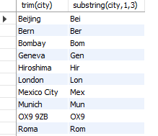
- Write a query to find employees whose LAST_NAME contains the letter 'n' and display their LAST_NAME along with the position of the first occurrence of 'n'.
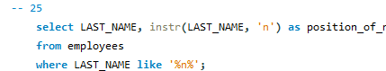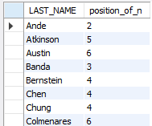
- Write a query to find the position of the letter 'a' in the FIRST_NAME for all employees. Display the employee's first name and the position of the letter 'a'.
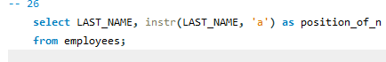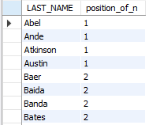

- Write a query to display the position of the first occurrence of 'e' in the JOB_TITLE for all jobs, and display only those where the letter 'e' occurs after the 5th character.
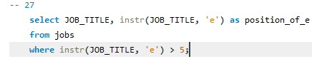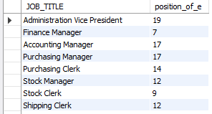
- Write a query to compare the FIRST_NAME and LAST_NAME of employees and display only those employees where the first name comes alphabetically before the last name.
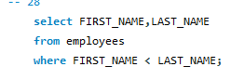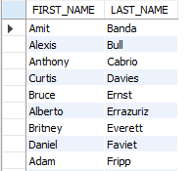
- Write a query to find all departments where the DEPARTMENT_NAME is either 'IT' or 'HR' using the FIND_IN_SET function.
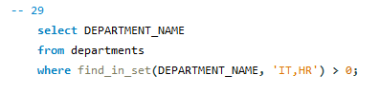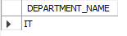
- Write a query to display the FIRST_NAME and the length of the name for employees whose FIRST_NAME length is greater than 6.
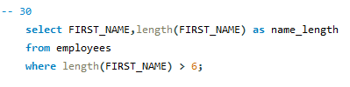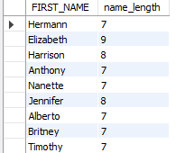

- Write a query to find all countries where the COUNTRY_NAME contains either 'China', 'India', or 'Japan'
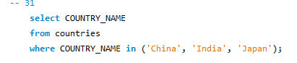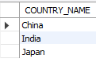
- Write a query to find all employees who have DEPARTMENT_ID present in the list (50, 60, 70)
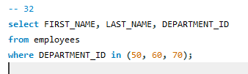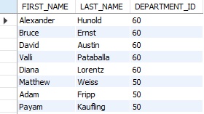

- Write a query to extract the first two characters from the COUNTRY_NAME function and the last two characters, displaying them along with the full COUNTRY_NAME.
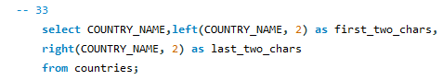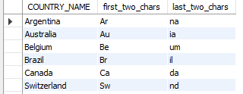
- Write a query to display employees whose LAST_NAME contains the letter 'o' at a position greater than half the length of their last name.
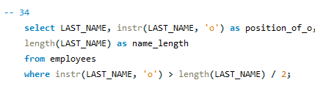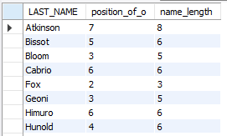
- Write a query to find employees whose FIRST_NAME contains the letter 'a' and the letter 'e' and display the positions of both.
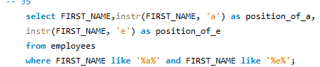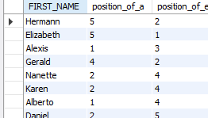
- Write a query to extract the domain from the EMAIL column for employees and only display employees whose domain is 'example.com'.
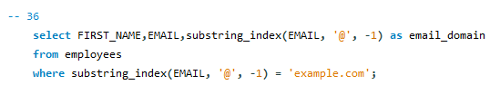
- Write a query to count the number of employees who belong to department IDs 50, 60, or 70
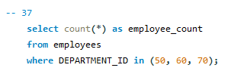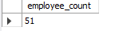
- Write a query to display all COUNTRY_NAMEs from the countries table where REGION_ID is either 1 or 3
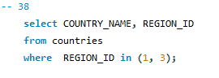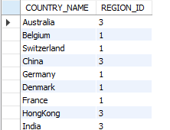
- Write a query to find employees who either work in departments 50, 60, or 70 or have a salary greater than 10,000.
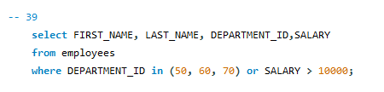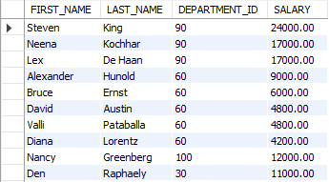
- Write a query to find employees whose DEPARTMENT_ID is either 50 or 60 and their MANAGER_ID is either 103 or 108.
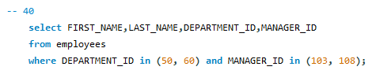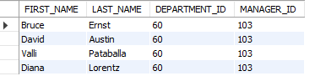
After Join/case Statement
- Write a query to display FIRST_NAME, LAST_NAME, and COUNTRY_NAME concatenated as a single string with a comma separating each.
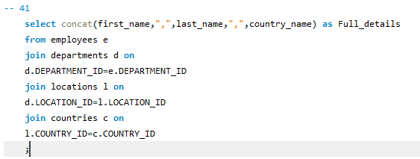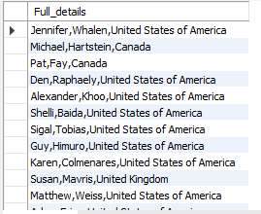
- Write a query to display the FIRST_NAME in uppercase for employees whose SALARY is greater than 8000 and the LAST_NAME in lowercase for employees whose SALARY is less than 8000.

